Activity 3: Navigation steps in Picture View

DESCRIPTION:
In this activity, I learned how to navigate through the ServiceNow application using Picture View. I opened the required module and selected the record needed for the activity. Then, I went through the different options and checked the record details. Finally, I verified that the navigation and required information were working correctly.
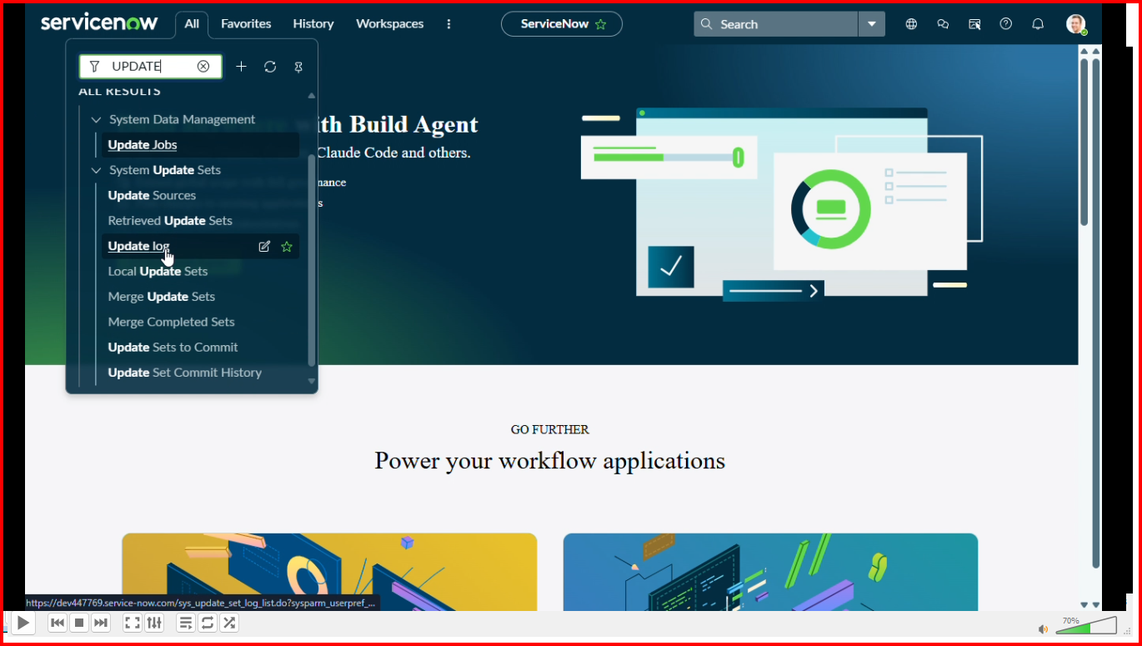

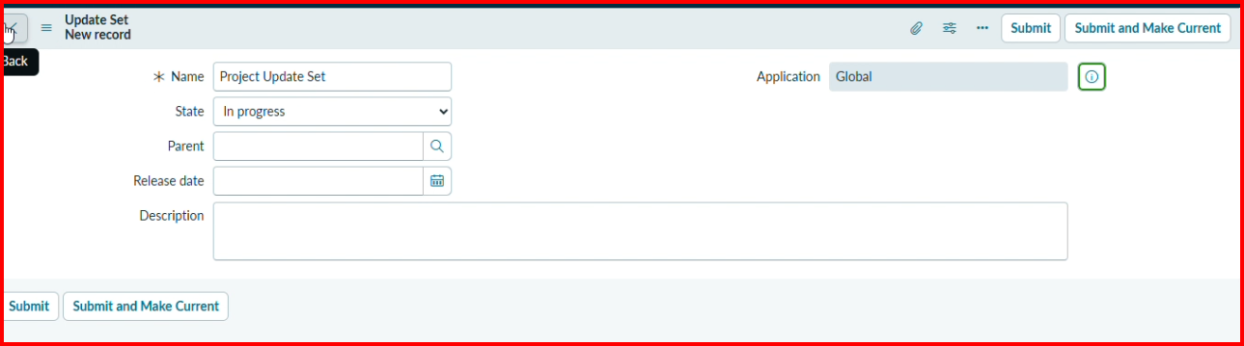

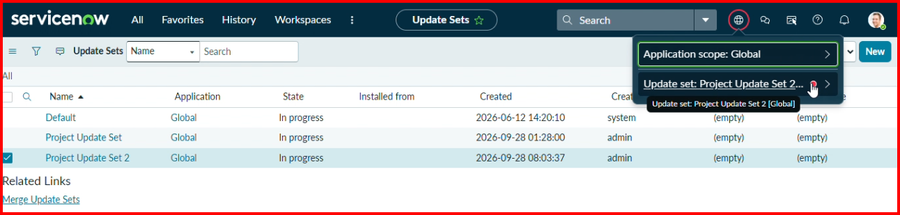

Finally, I navigated through the required options, verified the information, and completed the process successfully.

